|  |  |  |
| --- | --- | --- |
| POWER BI ASSIGNMENT | 2024 | |
| THE ANALYSIS OF CONSUMER PURCHASING DATA, USING THE POWER BI AND DETERMINED INSIGHTS FOR THE FURTHER DECISION MAKING BY THE ORGANISATION AND MARKETERS. PROVIDIONG A DETAILED REPORT ON THE FUNCTIONS AND CLASSIFICATIONS ON VARIOUS FACTORS USING VIZUALIZATION. | | CONSUMER PURCHASING BEHAVIOUR |

**SUBMITTED BY**: ISHA SRIVASTAVA (MBA 1-SEM) **SUBMITTED TO**: MR. SOURABH POSWAL  
CU I’D: CU24140089 (SEC-A) (FACULTY OF MANAGEMENT STUDIES)

**EXECUTIVE SUMMARY**

**BASIC OVERVIEW:**

Consumer purchasing behavior analysis in Power BI involves using data visualization, analytics, and business intelligence tools to understand consumer patterns and trends when making purchasing decisions. The analysis also explores customer demographics to understand buyer preferences. This report serves as a valuable tool for making informed decisions and optimizing sales strategies.

**METHODOLOGY:**

1. Data Collection

2. Data Modeling

4. Data Visualization

5. Analysis

6. Insights Generation

7. Reporting

8. Review and Iterate

This methodology provides a structured approach to analyzing car sales data, ensuring thoroughness and clarity in insights generated.

**KEY HIGHLIGHTS:**

• **Purchase by Region**: Visualization of purchase distribution across different geographical areas, highlighting top-performing regions.

• **Loyalty score**: Breakdown of loyalty score by region (e.g. north, south, east and west) to identify trends and preferences.

• **Customer segmentation**: Analysis of buyer profiles, including age and income levels, to understand target markets.

• **Purchase Trends**: Charts showing purchase frequency performance over time, identifying seasonal patterns and growth trends.

**TABLE OF CONTENT**

|  |  |  |
| --- | --- | --- |
| **SNO** | **TITLE** | **PAGE NO.** |
| 1 | **INTRODUCTION**  **-**CONTEXT  **-**OBJECTIVE | 1 |
| 2 | **DATA OVERVIEW**  **-**DATA SOURCE **-**DATA DESCRIPTION **-**DATA PREPARATION | 2 |
| 3 | **POWER BI [PROCESS]**  **-**DASHBOARD DESIGN **-**DATA MODELLING **-**VISUALIZATION | 4 |
| 4 | **INSIGHTS AND ANALYSIS**  **-**KEY INIGHT **-**BUSINESS RECOMMENDATION  **-**LIMITATION | 8 |
| 5 | **CONCLUSION** | 9 |

**INTRODUCTION**

**CONTEXT:**

Consumer purchasing behavior analysis is crucial in a business context for several reasons:

1. **Market Trends Understanding**: Analyzing sales data helps businesses identify trends in consumer preferences, such as popular models, features, and pricing strategies.
2. **Performance Evaluation**: Sales analysis allows companies to assess the performance of their sales teams, dealerships, and marketing campaigns.
3. **Customer Insights**: By analyzing customer demographics and buying behavior, businesses can tailor their offerings and marketing efforts to better meet the needs of their target audience.
4. **Forecasting**: Historical sales data can help businesses predict future sales, aiding in budgeting and financial planning. This foresight is essential for managing supply chain logistics and production schedules.
5. **Profitability Analysis**: By examining which models or categories yield the highest profit margins, companies can focus their efforts on the most lucrative segments of the market.
6. **Identifying Opportunities**: Sales analysis can reveal gaps in the market or underserved customer segments, providing opportunities for new products or services.
7. **Improving Customer Retention**: Understanding sales patterns and customer feedback can lead to improved customer satisfaction and loyalty initiatives, ultimately driving repeat business.

In summary, consumer purchasing behavior analysis informs strategic decision-making, enhances operational efficiency, and ultimately contributes to a business's growth and profitability.

**OBJECTIVE:**

The objective of using Power BI in a car sales analysis project is to provide a robust analytical framework that enables businesses to make data-driven decisions. Here are some specific objectives:

1. **Data Visualization:** Transform complex datasets into intuitive visualizations, making it easier to understand purchase trends, purchase frequency levels, and customer demographics.
2. **Real-Time Reporting:** Offer real-time insights into loyalty performance and income status, allowing for quick adjustments in strategy.
3. **Trend Analysis:** Identify and visualize trends over time, helping to forecast future sales and adjust marketing strategies accordingly.
4. **Performance Measurement:** Enable the tracking of key performance indicators (KPIs) for sales teams, inventory turnover, and customer satisfaction.
5. **Comparative Analysis:** Facilitate comparisons between different regions, salespeople, or car models to identify areas of strength and weakness.
6. **Enhanced Decision-Making:** Provide actionable insights that support strategic planning, such as pricing strategies, promotional campaigns, and inventory management.
7. **Collaboration and Sharing:** Allow stakeholders to share reports and dashboards easily, fostering collaboration across departments.
8. **Drill-Down Capabilities:** Enable users to drill down into specific data points for deeper analysis, helping to uncover root causes of performance issues.

By achieving these objectives, Power BI enhances the ability to tackle business problems effectively, optimize operations, and ultimately drive sales growth.

**DATA OVERVIEW**

**DATA SOURCES:**

In a car sales analysis project, various data sources can be utilized to gather relevant information. Here’s a brief description of each:

**1. Internal Database:** This includes relational databases (like SQL Server, Oracle, or MySQL) where historical sales data, customer records, inventory levels, and transaction details are stored. It provides structured data that can be queried for analysis.

**2. Online Database**: These are cloud-based databases (such as Azure SQL Database or Google Cloud SQL) that offer scalability and accessibility. They can host real-time data that can be integrated into Power BI for dynamic reporting.

**3. CSV Files:** Comma-separated values (CSV) files are often used to export and import data. They are simple text files that store tabular data and can be easily created and manipulated. CSV files might contain sales records, customer feedback, or market research data.

**4. Excel Files:** Microsoft Excel files are commonly used for data storage and analysis. They can contain various datasets, including sales figures, inventory lists, and performance metrics, and can be directly imported into Power BI for visualization and reporting.

**5. API Data Sources:** Some data may come from external services via APIs, such as market data, competitor pricing, or customer demographics from third-party platforms. These can be integrated into Power BI for comprehensive analysis.

By utilizing a combination of these data sources, businesses can create a holistic view of their car sales performance and derive valuable insights.

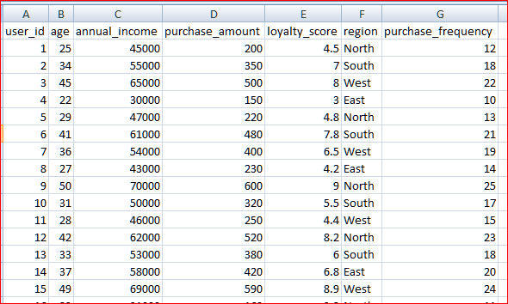

DATA DESCRIPTION:

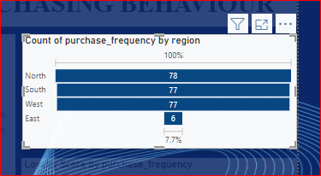**No. of rows:** 238

**No. of columns:** 7

**Key attributes:** user_id

• **Role**: This serves as a unique identifier for each vehicle in the inventory or sales database.

• **Usage**: It helps track specific car sales, inventory levels, and related attributes (like model, price, and features).

**DATA PREPARATION:**   
Cleaning data in Power BI involves several key steps to ensure that the dataset is accurate, complete, and ready for analysis. Here’s a typical workflow:

1. **Import Data:** Load your data from various sources (e.g., Excel, CSV, databases) into Power BI.

2. **Open Power Query Editor:** Access the Power Query Editor, where you can perform data transformation and cleaning tasks.

3. **Remove Unnecessary Columns**: Identify and remove any columns that are not needed for analysis, which helps streamline the dataset.

4. **Filter Rows**: Apply filters to remove any irrelevant or erroneous rows, such as duplicates or outliers.

5. **Handle Missing Values:** Identify missing data and decide how to handle it. You can fill in missing values, replace them with default values, or remove the affected rows.

6. **Change Data Types:** Ensure that each column has the correct data type (e.g., text, number, date). This step is crucial for accurate calculations and visualizations.

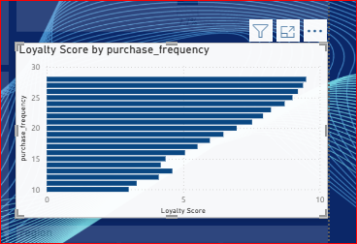7. **Trim and Clean Text:** Remove leading or trailing spaces from text fields and correct any inconsistencies in formatting (e.g., case sensitivity).

8. **Merge and Append Queries:** If necessary, combine multiple datasets (merge) or add rows from different sources (append) to create a unified dataset.

9. **Create Calculated Columns:** If needed, create new columns based on existing data for better insights (e.g., categorizing purchase frequency into ranges).

10. **Rename Columns:** Use clear and meaningful names for columns to make your dataset easier to understand.

11. **Check for Duplicates:** Identify and remove duplicate records to ensure data integrity.

12. **Sort and Organize Data**: Organize the data for better readability and accessibility, ensuring that it meets your analysis needs.

13. **Load Cleaned Data:** Once the data is cleaned, load it back into Power BI for analysis and visualization.

By following these steps, you can ensure that your data is reliable and ready for insightful analysis in Power BI.

**POWER BI [PROCESS]**

**DASHBOARD DESIGN:**

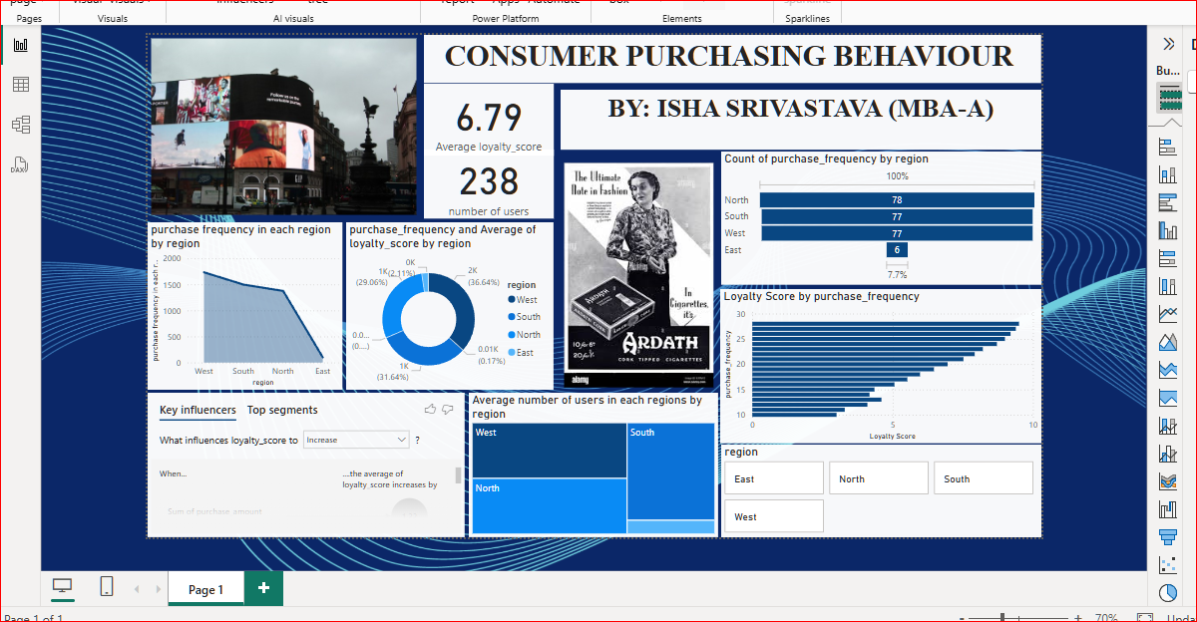

**(a)**

A Power BI dashboard consists of:

1. **Tiles**: Visual components displaying data (charts, maps, KPIs).
2. 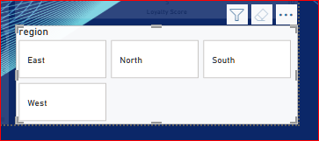**Visualizations**: Graphical representations like bar and line charts.
3. **Filters and Slicers**: Tools for user interaction to refine data views.
4. **Title and Description**: Contextual information about the dashboard.
5. **Navigation Pane**: Options to switch between different reports or dashboards.
6. **Refresh and Export Options**: Features to update data and export visuals.
7. **Alerts**: Notifications for significant data changes.

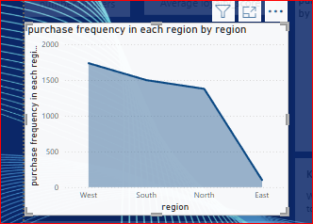

**VISUALS AND USER INTERACTIONS:**

1. **Card:** In Power BI, cards are a type of visual used to display key metrics or single data points. They provide a simple and effective way to present important information at a glance.
2. **Slicer/ filter:** Filters, especially advanced filters, are powerful tools to provide deeper insights and customization in Power BI, helping you and your audience focus on the most relevant data.

**3. Funnel:** It is particularly useful for understanding the conversion rates at each stage, identifying bottlenecks, and tracking where there might be opportunities to improve performance.  
 **DATA MODELING:**  **Measures**: Measures are calculations used for aggregations or summaries, dynamically evaluated based on the context (e.g., Total Sales, Average Quantity).  
**Hierarchies**: Power BI allows the creation of **Hierarchies** (e.g., Year > Quarter > Month) within a table to enable drilling down within visuals, providing better insights and more detailed analysis.

**Data Types**: Ensuring correct data types (text, numbers, dates, etc.) is critical for accurate calculations and relationships in the model.

**Primary Key**: A unique identifier for a record in a table e.g., USER_ID

**Relationships**: Relationships define how tables are connected in the model. Power BI supports three types of relationships:

* **One-to-many (1 :):** The most common type, where one table (the primary or "lookup" table) relates to multiple rows in another table (the fact table). Example: A table of products (lookup) might be related to a sales table (fact) where many sales records contain the same product.
* **Many-to-many (:):** In this case, both tables can have multiple related rows. Power BI now supports this type natively through composite models.
* 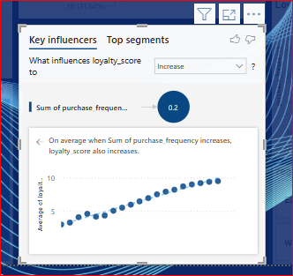**One-to-one (1:1):** Each record in one table corresponds to exactly one record in the related table.

**VISUALIZATION:**

1. **Donut chart:** is a circular statistical graphic which shows how parts related to a whole.
2. **Card:** an effective way to represent the important information in a simplest and convenient way, here it represents number of users and average loyalty score.
3. **Funnel:** helps to represent the data from largest to smallest, in this report purchasing frequency is determined by the region, which region have the highest purchasing frequency to the lowest.
4. 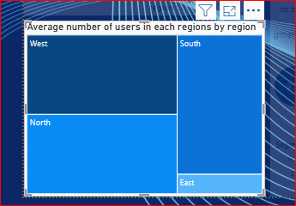**Slicer:** provide simple way to analyze the data on a single glance here it is used in loyalty score.
5. **Key influencer:** helps to determine the detailed insight for the further decision and strategy formation, it analyzes the data, ranks the factors that matters and display them.
6. **Tree map:** this rectangle shaped tool, provide the areal representation of the data to know the hierarchy level, where colored rectangle represents branch node.
7. **Stacked area**: it is often used to visualize trend in a data over time, stacked area is used to display how several quantities combine to make a whole.

**INSIGHT AND ANALYSIS**

**KEY INSIGHTS:**

1. **Consumer segmentation:** This insight, provide the overview on the consumer frequency in different regions.
2. **Purchasing churn indicator:** A decrease in purchasing frequency or the absence of repeat purchases could indicate potential customer churn and vice versa.
3. **Geographical preferences:** Certain products may be more popular in specific regions or locations. In this insight these geographic regions are divided into four regions where west and north are the regions with highest consumer frequency.
4. **Loyalty score:** this slicer helps to determine the loyalty score of the consumer based upon the different purchasing amount and frequency and annual income.

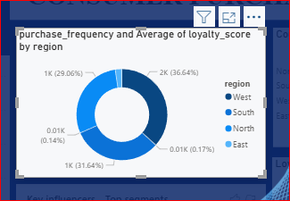**BUSINESS RECOMMENDATION:**

1. **Personalized Marketing Campaigns**: Tailor marketing strategies to specific customer segments based on purchasing history and behavior.
2. **Customer Retention & Loyalty Programs**: Implement loyalty programs and reward repeat customers to enhance customer lifetime value (CLV).
3. **Dynamic Pricing Strategy**: Use sales trends and seasonality to adjust pricing and maximize revenue during peak demand periods.
4. **Targeted Discounts & Promotions**: Offer discounts or promotions based on customer behavior, such as cart abandonment or purchase frequency.
5. **Inventory Management & Stock Optimization**: Forecast demand using purchasing trends to optimize stock levels and prevent stock outs.
6. **Geo-Targeted Promotions**: Implement location-specific offers or product recommendations based on regional preferences.
7. **Improved Customer Segmentation**: Create refined customer segments to target specific groups with tailored products and marketing efforts.

**LIMITATIONS**:

• **Real-Time Data Processing**: Power BI is not ideal for real-time analytics, leading to delays in refreshing sales data.

• **Complex Data Models**: Large datasets can complicate data models and slow report performance.

• **Limited Advanced Visualizations**: Power BI has basic visualizations, and complex or custom visuals may require external tools.

• **Basic Forecasting Capabilities**: Power BI’s built-in forecasting tools are limited compared to advanced predictive analytics platforms.

• **User Skill Level**: Non-technical users may struggle with complex analysis, often relying on IT teams for report modifications.

• **Geospatial and Regional Analysis**: Geographic analysis might not be sufficiently detailed, limiting insights into dealership or regional performance.

• **Security and Governance**: Managing data privacy and access control can be challenging, especially with sensitive customer data.

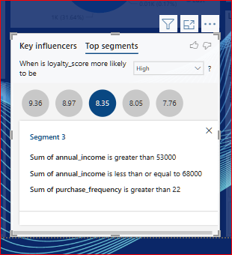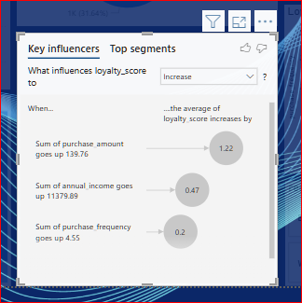

**CONCLUSION**

In conclusion, while Power BI is a powerful tool for consumer purchasing behaviour analysis, it does face limitations related to data quality, real-time processing, complex data models, and basic forecasting capabilities.

Users may also encounter challenges with advanced visualizations, geographic analysis, and ensuring security and governance. However, these limitations can be mitigated through better data integration, simplifying models, leveraging external tools for advanced analysis, and providing user training.

By addressing these challenges, businesses can unlock more accurate insights and make data-driven decisions to improve their sales performance.

**`**